# Package Installation Guide

## Step by step guide to install and update packages

This section will detail the system requirements and UiPath packages to be available in the system to ensure that it executes the codes correctly. Follow the steps to install the package in UiPath studio:

**Step 1.** Click on Manage Packages.

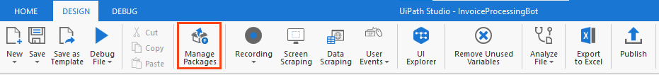

Figure 1 Manage Packages Ribbon Bar

**Step 2.** Search the package according to the project requirement.

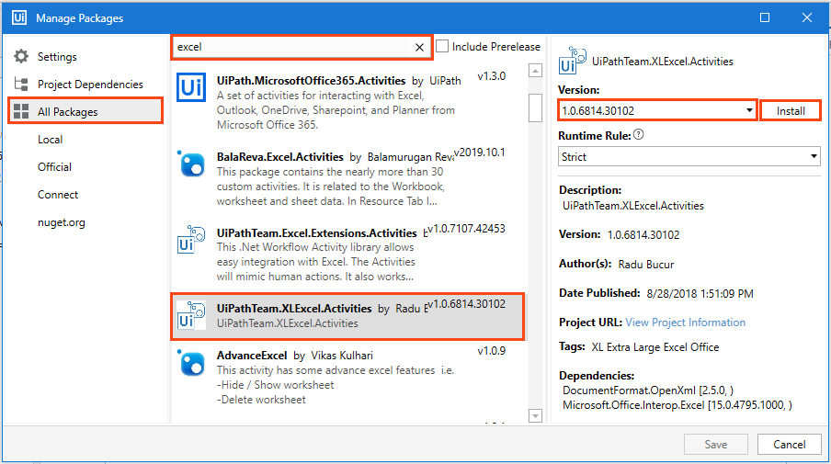

Figure 2 Package Installation

**Step 3:** Select the package and the version to be installed.

**Step 4:** Save the packages by clicking on the “Save” button.

## Viewing list of installed Packages

To view the packages used in code, right-click on the “Dependencies” option of “Project” panel and select “Manage” option (refer Figure 3).

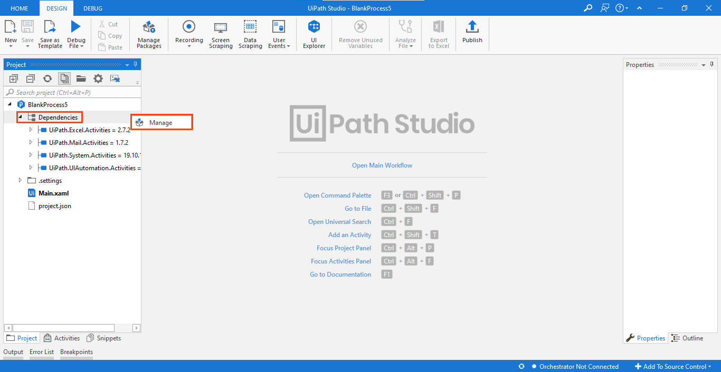

Figure 3 Installed Packages List

Note: For the codes which involve browser usage, the browser should have its extension installed. You can install an extension from the 'Tools' section of UiPath Studio.

# Basic Projects

## Stock-Broker Robot

The code comprises of three packages (refer Table 2), and they must be installed in the studio for the Robot to execute the task successfully.

|  |
| --- |
| * Uipath.Mail.Activities * UiPath.System.Activities * UiPath.UIAtuomation.Activities |

Table 2 List of packages used in ‘Stock Broker’ Robot

The above-listed packages used can be viewed on the left side of the "Project" panel tab (refer Figure 6).

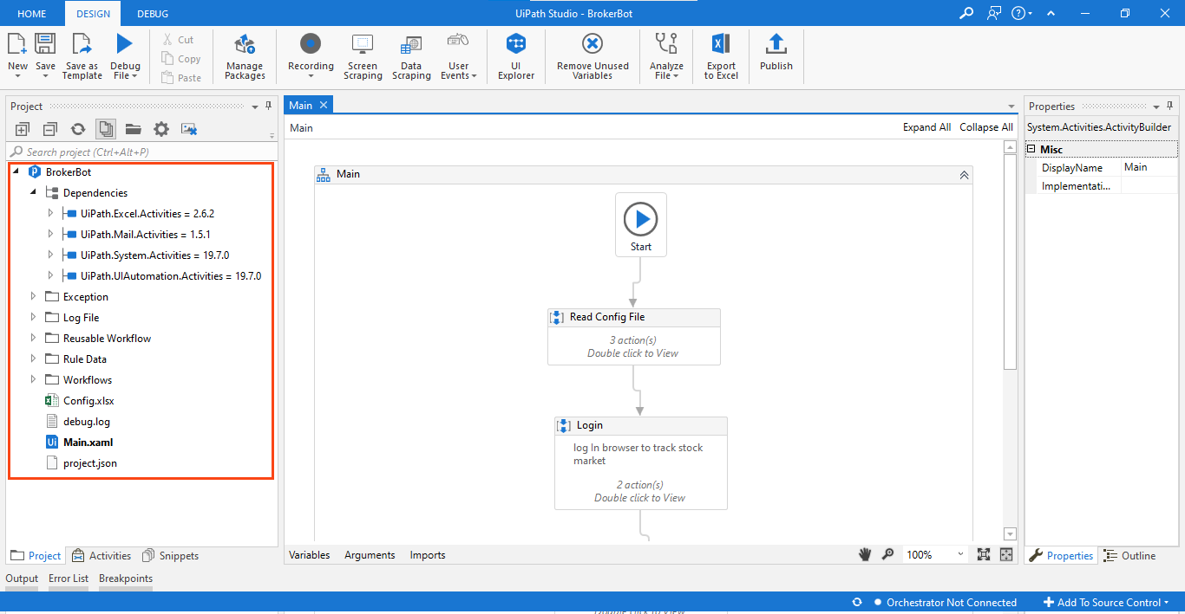

Figure 6 List of packages used in Stock Broker Robot

Right-click on "Dependencies" and select "Manage" to view all project dependencies (refer figure 7).

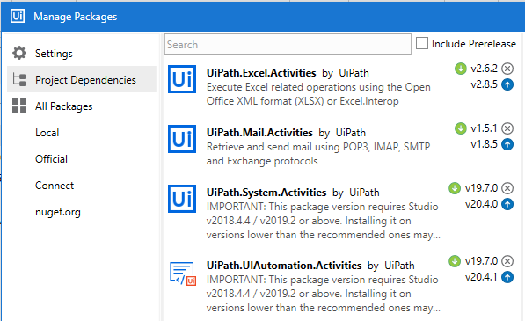

Figure 7 Project Dependencies in ‘Stock Broker’

**Note: If a package appears in 'Red' it indicates a problem. To resolve it, right-click on the package name and click resolve/update**

**Prerequisite:**

Insert the Recipient Email address in the ‘**Values’** column of ‘**Config.xlsx**’file.

Google Chrome application should be installed on your system.

To install Google Chrome extension, open the Uipath studio, then click on the tools option and then enable the Google Chrome extension by clicking on the icon in the list of extensions.

The ‘**offer to save password**’ option should be disabled on the Chrome Browser.

The Project folder has a ‘**config.xlsx’** file containing the URL of ‘rpachallenge.com’ stock market page and the email address from where the email is to be sent. To make the necessary changes, please enter the URL and the email address in the **config** file.

The Project folder has a ‘**rule.xlsx’** file containing the headers ‘Company Name’, ‘Price’ and ‘Action’. The user can enter the ‘Buy’ or ‘Sell’ actions.

## Process Flow Chart

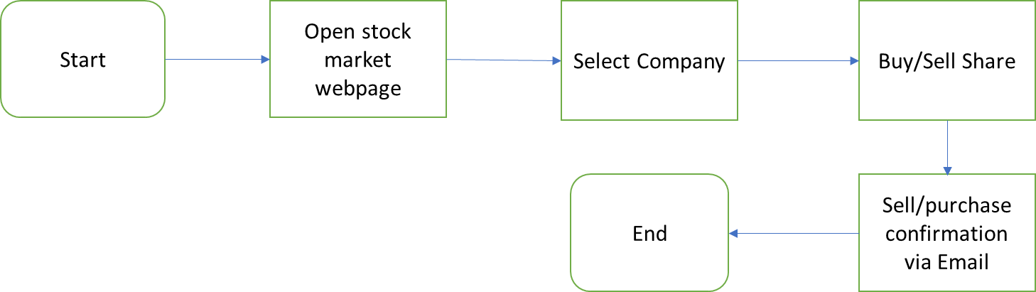

## Applications to be used



Based on the scope, applications to be used for Stock-Broker Robot are:

**1. UiPath Studio:** Used to create the Robot.

**2. Web Browser:** Used to open stock broker webpage.

**3. MS Excel:** Used to read rules and configuration for the Robot.

**4. MS Outlook:** Used to send sell/purchase confirmation email.

## Process steps

**Project Overview:** This project aims to build a Robot that buys and sells shares on a stock-broker website. The Robot searches for current prices of the company shares as per rules in the excel file. It further tracks the values and performs actions which are stated in the ‘Rule’ file.

The ‘Rule’ file used in the code has the below mentioned fields:

Company name

Price

Action – Buy or sell

Rule set for the Robot to Action:

Buy – The robot will check the current price of the share mentioned in the excel file and if it is less than or equal to the price mentioned in the file, then it will buy the shares.

Sell – The robot will check the current price of the share mentioned in the excel file and if it is greater than or equal to the price mentioned in the file, then it will sell the shares.

## Steps make a Stock-Broker Robot:

**Step 1:** The Robot will open the stock market webpage of RPAChallenge.com website.

**Step 2:** On the webpage, it searches for the shares of the companies mentioned in the ‘rule.xlsx’ file.

**Step 3:** It will then check the current price of the share and compare the values mentioned in the ‘Rule’ file.

**Step 4:** After comparing the prices, it will further perform the action mentioned in the ‘rule.xlsx’ file i.e. either buy or sell.

**Step 5:** Once it completes the action in the ‘Rule’ file, it sends confirmation through email.

## Appendix

**1. What is Stock**

Stock is the shares in which the ownership of a company or corporation is divided. Shares are small portion of the company that gives you a small ownership in the company.

**2. What is Share Market**

The share market is where the shares of various companies are sold or purchased.